Dear Friend and Neighbor

Our beloved Sheltie escaped our home on Sept 4th, 2011 and we are desperately searching for him/her. A Sheltie looks like a miniature collie (Lassie). He/she weighs xx#s, see picture below.

Shelties are very shy and scared, and will seek out quiet, dark places to hide in, and seldom will they come to a stranger.

We are asking for your help!! Would you please search your property for him/her?
Under your deck, in your shed, in a corner of your garage, in heavy brush, under a car, in your barn? Any place a small dog (25#s) could curl up and HIDE.
If you see him/her – DO NOTHING- except call us right away. He/she will RUN if you try and touch or grab him. PLEASE CALL US WITH ANY SIGHTING, NO MATTER HOW BRIEFLY YOU SEE HIM.

LOST SHELTIE (MINIATURE COLLIE) $500 REWARD
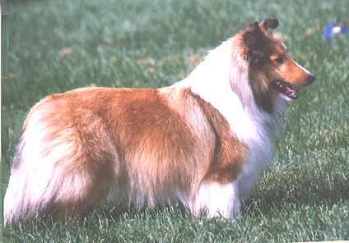

MICROCHIPPED
Female, 30 pounds, sable
Police are involved.
We would be most grateful for any help you an offer.
Your neighbor,
Susie and John Doe  123 Sesame St.  Yourtown, USA | Phones  TEXT ME @ 000-0000  EMAIL ADDRESS

