Dear Vet Clinic, Animal Facility…

Our beloved Sheltie escaped our home on Sept 4th, 2011 and we are desperately searching for him/her. A Sheltie looks like a miniature collie (Lassie). He/she weighs xx#s, see picture below.

If you happen to get this dog into your Clinic, or if someone happens to come in with a
“New Sheltie”…….please compare this flyer with ANY NEW SHELTIE YOU GET IN,
LOST or STOLEN SHELTIE (MINIATURE COLLIE)
$500 REWARD
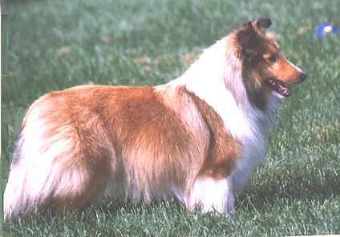

MICROCHIPPED
Female, 30 pounds, sable
Police are involved.

We would be most grateful for any help you can offer.
Susie and John Doe  123 Sesame St.  Yourtown, USA | Phones  TEXT ME @ 000-0000  EMAIL ADDRESS

