$500 REWARD
LOST SHELTIE
(MINIATURE COLLIE)
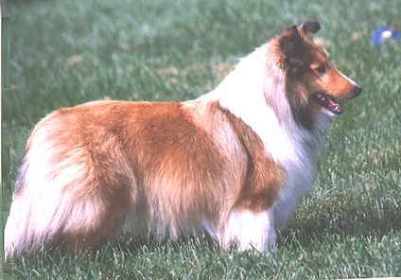
(use a full body photo if possible, as this is what someone would likely see)
WILL RUN IF CHASED – CALL WITH ANY SIGHTINGS!!
PHONE NUMBER

